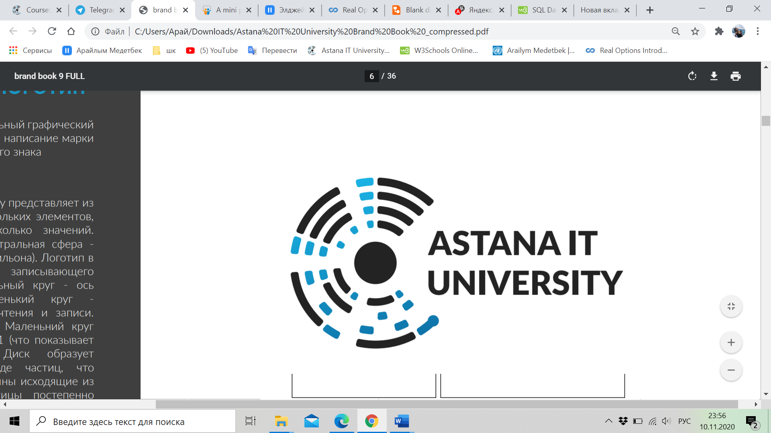

Nur-Sultan, Kazakhstan

IT Management 2020

WEB Technologies

**Website of AITU-Canteen**



**Group name:** ITM 2005

**Students:** Medetbek Arailym, Izglikov Abylaikhan, Kalkaman Bakytzhan, Nurakhunov Kurban, Kaskin Daniyal

**Teacher:** Salkenov Aldiyar

**Table of contents**

|  |  |  |
| --- | --- | --- |
| Content | | Page Number |
| #1 | Introduction | 3 |
| #2 | Overview | 4 |
| #3 | Project goals and team interests | 5 |
| #4 | Phases: | 5 |
| #5 | Content structure | 6 |
| #6 | Summary | 13 |
| #7 | Reference | 14 |

Introduction

In our century “time” is really important value, which owns people and confidently, everyone wants to economize as much as possible time. Even, people started to try to spend less time in the queue. For example, instead of waiting the order in restaurants or cafes, people usually admire to order meal to their house. Properly, this scheme is actual to the university canteens, too.

The website of University Canteen is the project, which gives availability to user, in this case to students and employees of the AITU, save their time and develop the rate of the service in the canteen. By this it is meant that people can spent less time in the “long” queues and respectively, the level of “stress” among customers will decrease. Thus, the percentage of not satisfied customers will decline.

Overview

* **About your team** – The team number 1.
  + **Members and their roles**1.Medetbek Arailym- 204013, responsible to the documentation part of the project, araika2402@gmail.com  
    2.Kalkaman Bakytzhan- 204036, responsible for HTML code  
    3.Nurakhunov Kurban- 204069, responsible for HTML and CSS code  
    4.Izgilikov Abilaykhan – 204108, responsible for the design of the website, Aboizg@mail.ru   
    5.Kaslin Daniyal – 204053, responsible for CSS code,
  + **Communication strategy**   
    1. Created special chat in the platform “Telegram” to share with the information, which is connected to the project.  
    2. Meetings in the platform “Microsoft Teams” everyday in the purpose of identifying the completed work.  
    3. The meetings after lessons to discuss some points, such as design or problem with code – once in 2 day.
* **Motivation**   
  The topicality of the project can be evaluated in the high level, because the creature of such kind of project makes the life of students and employees of Astana IT University make more convenient. Moreover, it should be profitable to the canteen, because the number of customers will increase because of pre-order.
* **High-level project scope**   
  The created project should be considered as brand-new website, due to it was created from white page.
* **Target audience/market**   
  As the main audience is regarding the students of Astana IT University and the employee of this educational center, cause canteen is located in this building and now, it is not possible to enter in to other people, because of the COVID-19 situation.

Project goals and team interests

Project goals:

* To create the website of the canteen
* Increase the number of clients to 20%
* Develop the relationship and connection among canteen employees and customers.
* Decrease the cluster of people, which occurs in the queue to the food.

Team interests

* Understand HTML tags and CSS by building a canteen website
* Establish a solid understanding of website design principles
* Improve team working skills by collaborating with different members of the group
* Improve the communication skills by working as teem and collecting information from different sources

Phases:

Phase 1- The creature of the website design in the program Photoshop by adding photos of the good, which can be find in the canteen

Phase 2- Basic website of Canteen by applying the HTML

Phase 3- The adding styles to the website by applying CSS and animation by Bootstrap

Phase 4- The documentation part of the project

Phase 5- Pre-test of the created website before distribution

Phase 6- Distribution of the website among audience and utilization

Content structure

**Site map**

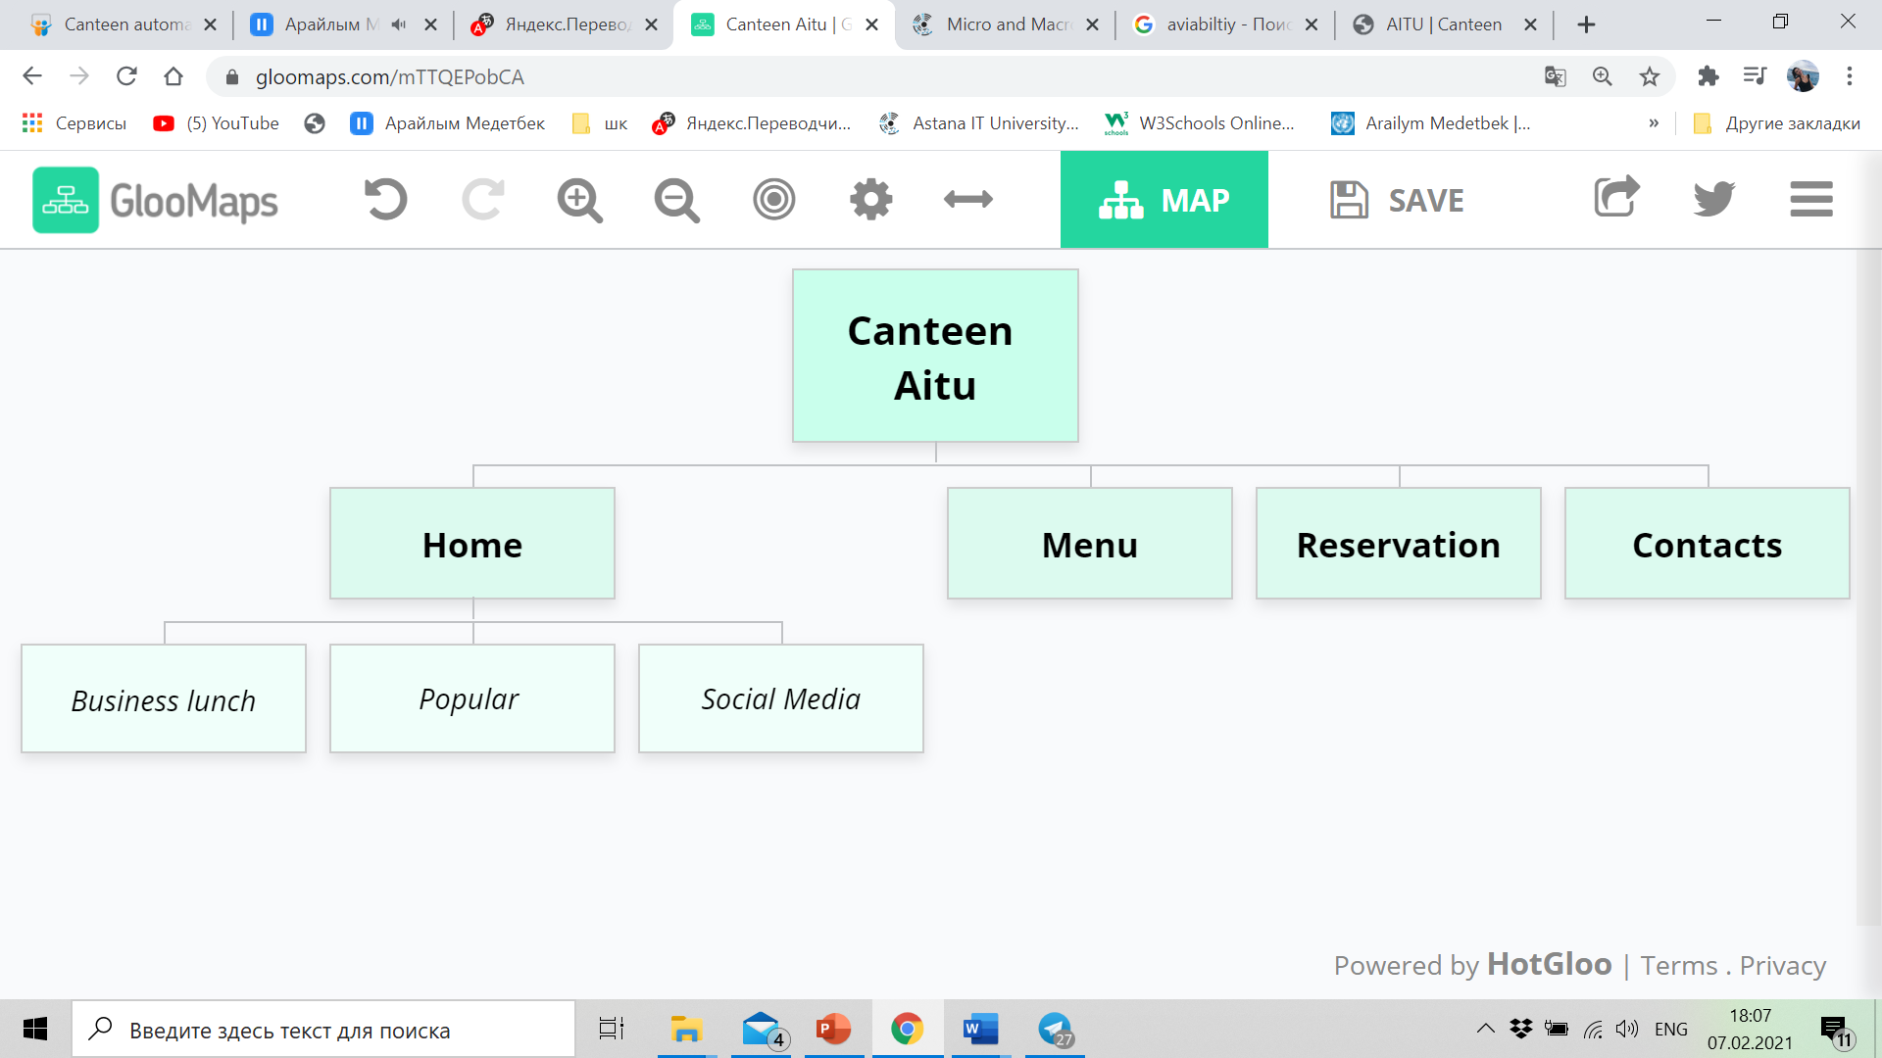

As it can be mentioned from the supplied illustration, there will be 4 main parts of the website, such as Home page and page of Menu, reservation and surely, contacts, by which can be created the line of connection. Moreover, the Home page will consist the different part, like business lunch, popular items of the canteen and social media photos.

**Content types**

* 1. Photos of business lunch
  2. Price of meal
  3. Menu of the canteen
  4. Social media of the canteen

**Design**

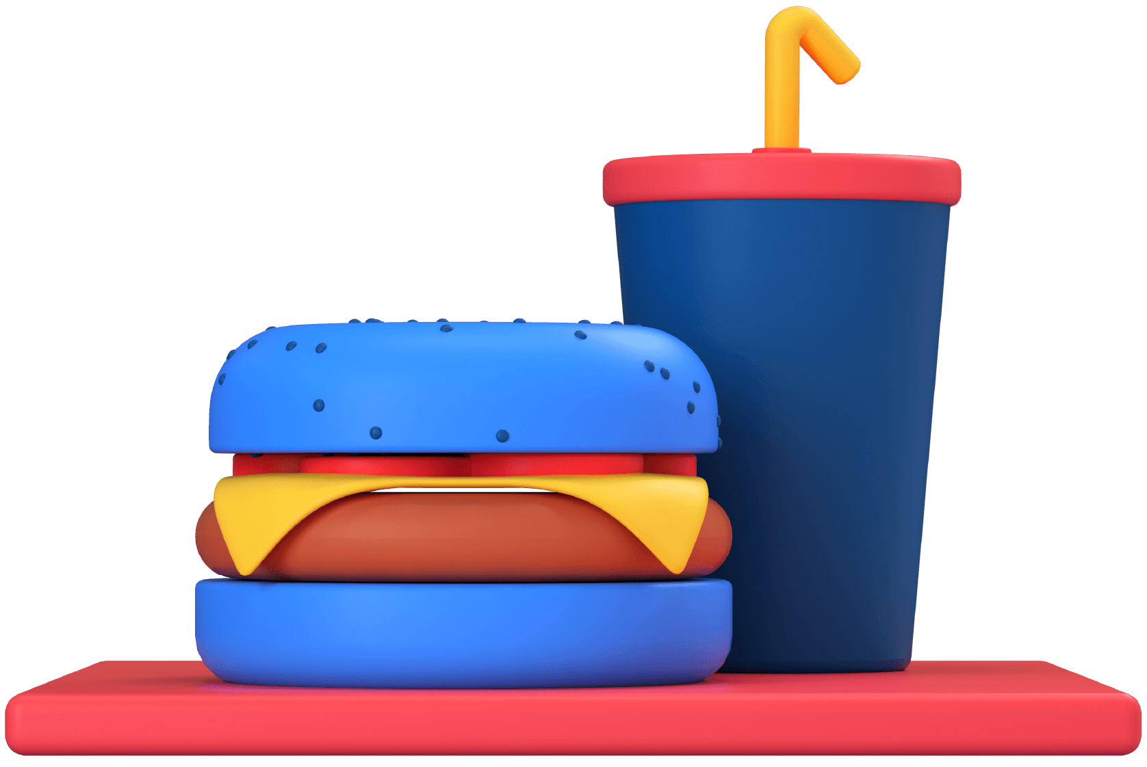

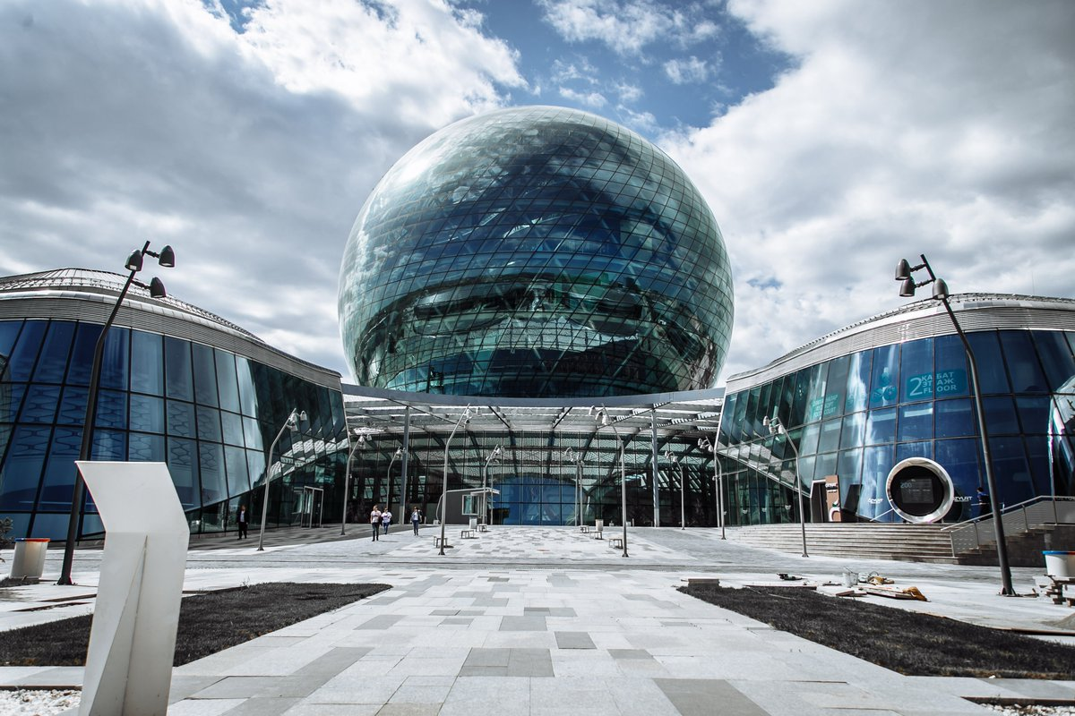

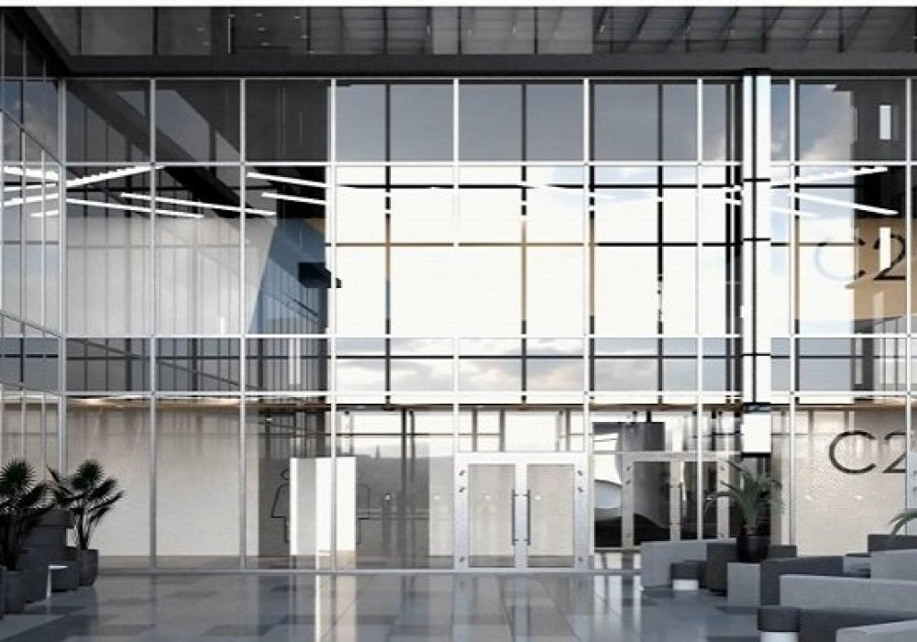

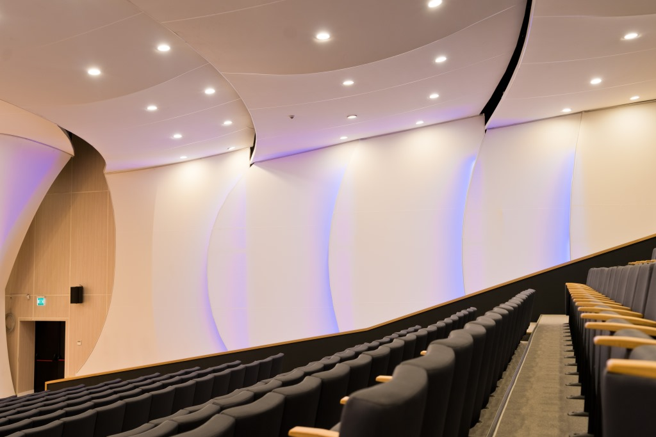

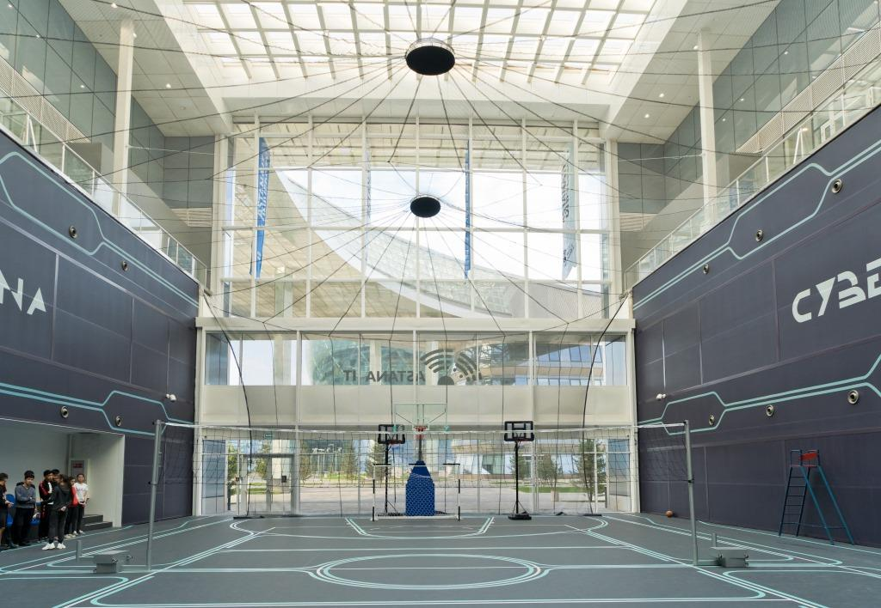

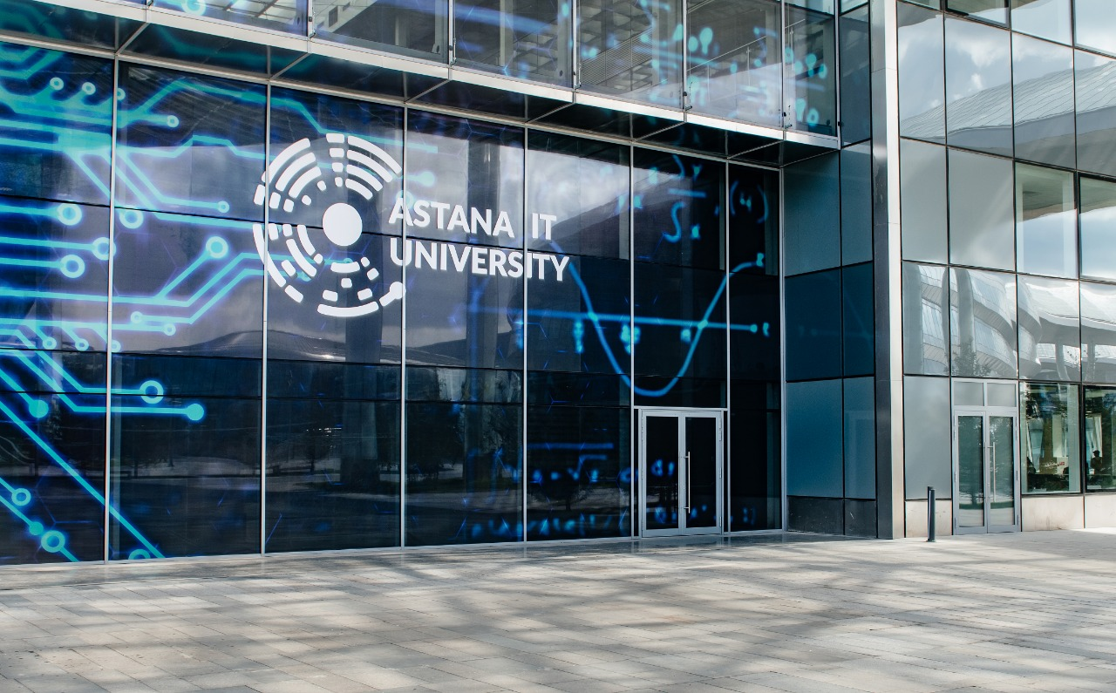

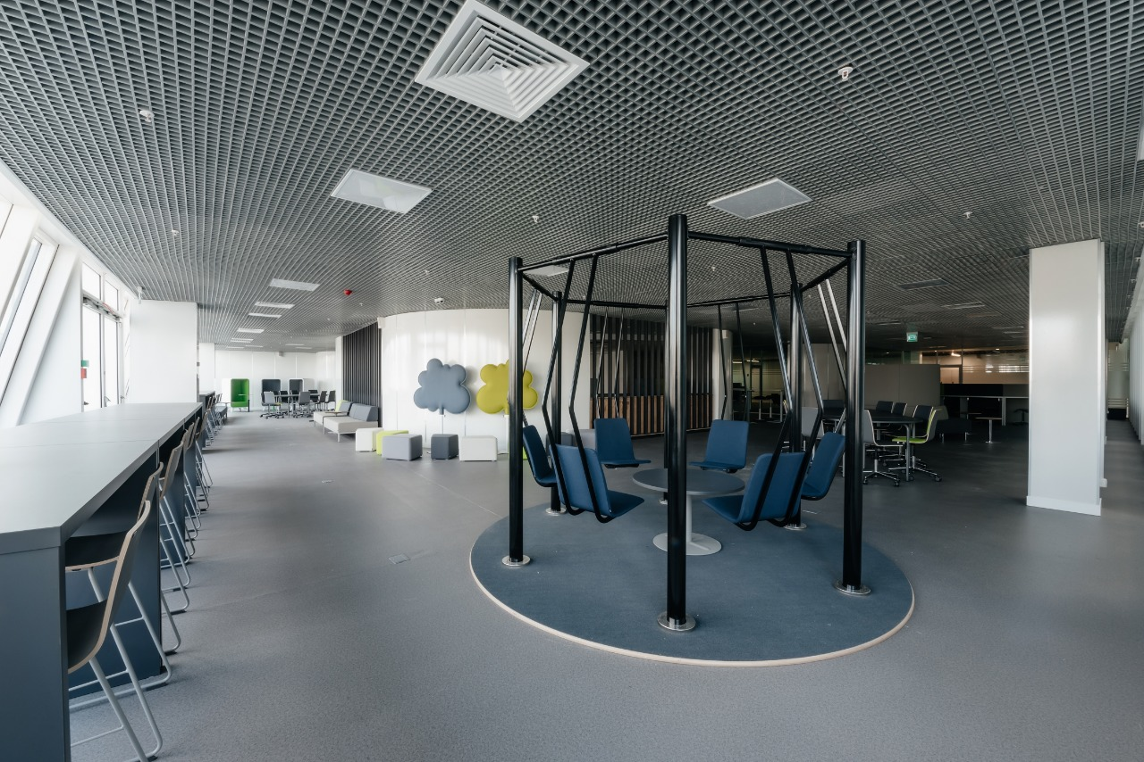

**Used colours:**   
#FF4E50 ~ Radical Red   
#f2f2f2 -Gray95  
rgb(42, 131, 248) – unknown color   
rgb(78, 160, 255)- unknown color  
#163ec2 – unknown color

**Functionality**

The presented website gives opportunity to the user order meal before the time and look at the today’s menu and compare the prices of each good. Moreover, user-friendly interface allows to the customer find and manipulate with the information like popular food and business lunch, which can be ordered in the university canteen. Confidently, there are reservation box, which aids to the user reserve portion of any food, which he wants. Besides, it should not be forgotten that the website provides contacts of the canteen, that can help to set up a relationship among businessmen and potential client.

For reservation page it is required to write the Name, telephone number, reservation time and email- address.

**Hosting**

The website was uploaded to the GitHub. So, the steps, which have done to uploading the file are:

1. Creating the new repositorie
2. Giving the name to it and changing the type to the public
3. Uploading the HTML and CSS files, also all images which has been used
4. By GitHub pages changing to the “root”.

**Accessibility**

All used colors and fonts are chosen specially, in this way that it can be easily read and there will not be any discomfort to the users of the website.

**Deadlines**

* Phase 1- 1.02.2021
* Phase 2- 2.02.2021
* Phase 3- 3.02.2021
* Phase 4- 5.02.2021
* Phase 5- 6.02.2021
* Phase 6- 7.02.2021

Summary

In conclusion, it can be summarized that our group can achieve to its goal, because we have created the website of the canteen, which can automize the working system of canteen. In the pre-test phase, all the expectation has been met. It means that the website works in the correct way and performs all tasks, which is required.

In general, all group members can achieve to their goals, taking into account that the project has competed in 2 weeks. The first thing, which was completed by members of our group is working as one “organism”, finding compromise and listen each other. Surely, at the start there were some issues, due to everyone has got his own idea and point of view, but in the process, we can find one common language. As the second thing, which we have covered is applying our theoretical knowledge in the HTML and CSS languages in the practice, by creating the website of university canteen.

References:

1. GitHub
2. Astanait.edu.kz
3. Google fonts
4. gloomaps.com